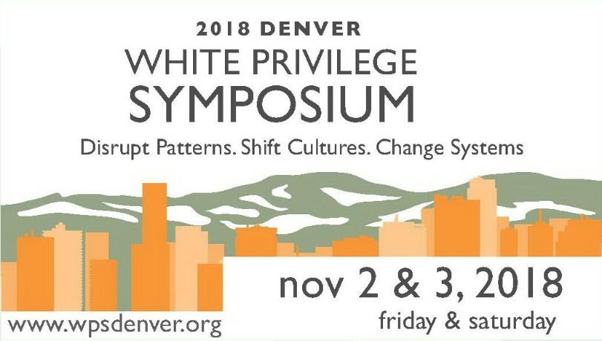
Symposium Rates (group discounts and moore on the website)

Friday Evening Community Event at The Sheraton Downtown
- Open to all!! (no charge)
Saturday Symposium at The University of Denver REGISTRATION
- Corporate/Professionals: $145 OPENS
- Individual/Educator/Non-Profit: $110 LABOR DAY!
- College Student: $75
- High School Student (in the Youth Action Project): $60
Saturday Friendraiser/Fundraiser at The University of Denver
- Adults: $65 Students: $35.00
Schedule of Events
Friday, November 2, 2018 Community Wide Event
5:00 pm Registration and Exhibits
6:00 pm Welcome and Introduction
6:30-8:30 Keynote and Edu-tainment featuring Dr. Frederick Gooding (aka The Race
Doctor), Jasiri X and Moore

Saturday, November 3, 2018 White Privilege Symposium - Denver
8:00 am Registration and Exhibits
9:00 am Indigenous Welcome and Keynote by Dr. Kathy Obear
10:30 am Workshop Presentations Session 1
11:45 am Lunch and Exhibits
12:45 pm Lunch Keynote by Theo Wilson
1:30 pm Workshop Presentations Session 2
3:00 pm Workshop Presentations Session 3
4:30 pm Closing and Next Steps

#20Moore Years: Friendraiser and Fundraiser for The Privilege Institute
5:45 pm This special event includes heavy refreshments, exhibits, a silent auction, door
prizes, and a unique opportunity to listen, learn and engage with many of our
keynote speakers, workshop presenters and performers.
7:00-9:00 Edutainment Featuring Dominique Christina, Jasiri X and Moore

