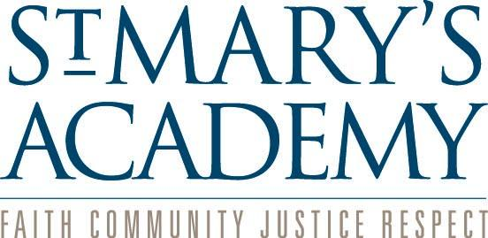
St. Mary’s Academy
Employment Posting

Job Position: Middle School Learning Specialist (math, executive function, and ADD/ADHD emphasis)

St. Mary’s Academy Overview:
St. Mary’s Academy, located in Englewood, Colorado is Metro Denver’s premier Catholic, independent school offering rigorous academics in its co-ed lower and middle schools, and its high school for girls. St. Mary’s Academy offers a safe, yet innovative program that embraces all student backgrounds, and fosters character and moral development from Pre-Kindergarten to Graduation.

St. Mary’s Academy is a close community where faculty and staff serve as role models for the students in accordance with a mission to foster excellence in each child through academic achievement, spiritual development, and service. The qualities of a strong work ethic, desire for personal growth, and commitment to life-long learning that St. Mary’s Academy expects of students is likewise an expectation for faculty and staff. Each day, too, is an opportunity to live the Loretto School Values of faith, community, justice, and respect.

St. Mary’s Academy is committed to recruiting and retaining a diverse faculty and staff who are dedicated to their profession and to the well-being and life of the St. Mary’s Academy community. Additionally, St. Mary’s Academy is committed to training and supporting faculty in the creation of inclusive classroom spaces. St. Mary's Academy does not discriminate on the basis of age, color, sex, disability, marital status, national or ethnic origin, race, sexual orientation, or religion. This policy applies to all areas of student concerns: educational policies, admission policies (historically high school admission is open to women only), scholarship, and grant-in-aid programs, athletic and other school-administered programs as well as employee/personnel concerns. St. Mary's Academy is an equal opportunity employer.

Job Description:
St. Mary’s Academy is seeking a Middle School Learning Specialist. This position will directly support students with diagnosed specific learning disabilities such as dyscalculia, students with other neurodiverse learning profiles impacting progress in mathematics, and students with significant deficits in mathematical abilities. This person will also support students struggling with executive functioning skills as well as students diagnosed with attention concerns. The learning specialist will assist in developing and maintaining an effective educational program consistent with the SMA philosophy, policies, and goals. The learning specialist will work collaboratively with students, parents, faculty, and staff; maintain records and files; and prepare reports. This position reports directly to the Assistant Principal and collaborates with the Middle School Learning Specialist Team.

Major Duties and Responsibilities:
- Review and evaluate the needs of children using psycho-educational evaluations, standardized testing, and informal observations.
- Work with students, faculty, and families to devise strategies to best support the needs of individual students.
- Teach four to five sections of academic support and enrichment, in both pull-out and push-in models. Provide small group math intervention..
- Provide small group intervention to support students with executive function deficits and/or AD/HD.
- Work with teachers to identify students who would benefit from intervention beyond the regular classroom.
- Support grade-level teams and attend grade-level meetings; develop faculty presentations relates to research, best-practices, etc. as appropriate.
- Create accommodation plans, update plans, and host yearly formal accommodation meetings.
- Formally monitor students receiving intervention and those who could potentially benefit from intervention.
- Host formal and informal conferences with parents to keep them abreast of their child’s progress.
- Manage materials for, follow protocols of, schedule, and administer standardized testing
- Teach, co-teach, and model instruction in classrooms.
- Perform various additional duties in support of students, faculty, staff, and the Principal.

Qualifications/Requirements:
Education and qualifications should include the following:
- Five or more years of experience teaching neurodiverse and learning disabled middle-school students one-on-one, in a small-group intervention setting, and in a full classroom environment.
- Demonstrated expertise in math development and intervention.
- Master's degree, post-graduate work, or extensive professional development in education with an emphasis on varied exceptionalities or learning disabilities preferred.
- Experience interpreting psychoeducational evaluations; writing and monitoring accommodation plans, and monitoring student progress.
- Excellent interpersonal and communication skills.
- Genuine enjoyment of the adolescent stage of development.
- Demonstrated passion for nurturing and empowering neurodiverse learners.
- Demonstrated passion for and commitment to learning about, supporting, and celebrating all forms of diversity in the classroom and in the school environment at large.
- Experience with students who are Twice Exceptional is preferred.

Salary/Benefits:
The salary range for this full-time, exempt position is $43,000.00 - $68,000.00. St. Mary’s Academy provides excellent benefits, including medical, dental, and life insurance, retirement, paid time off, tuition remission, and opportunities for professional development.

How to Apply:
Interested candidates should send a cover letter and resume and statement of educational philosophy to Ellen Hertzman, Middle School Administrative Assistant; ehertzman@smanet.org. No calls, please.

